Level 0 DFD
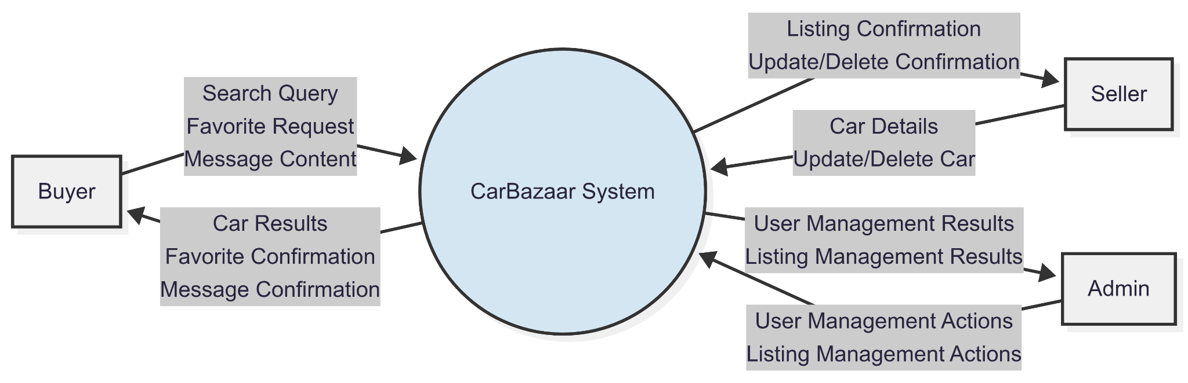

Level 1 Buyer DFD
